GCP training progress

10:00 AM to 2:00 AM

11:30 (20 min)

-------------------

- create an instance

- image: ubunut 20.04

disk: 10 gb

- default (network)

- firewall (http)

-------------------

2. create a key using putty-keygen and attach the key to the instance

download the private key and access via putty

3. install nginx

apt update -y && apt install nginx -y

4. install docker in the machine (ubuntu)

https://docs.docker.com/engine/install/ubuntu/

5. create a container

docker run -dt --name web1 -p 88:80 httpd

docker ps

6. create a firewall-rule

- targets - all machines in the network

- source: 0.0.0.0/0

- all-ports

7. access the container

machine-public-ip:88 (browser)

==========================================================================

lab: Create an image and a template

1. create an images

-- images >>> select the vm

2. create a template

- select the above image

- machine-type: e2

- default

- keys: public-key

3. access the machine and check the packages

========================================================================

Day 2

========================================================================

1. create an instance template

2. create an instance group

- min: 1, max: 4

Signal: cpu :40

3. access the machine and install stress package

apt update -y && apt install stress -y

stress -c 2

4. see the number of instances created

**Instance template:**

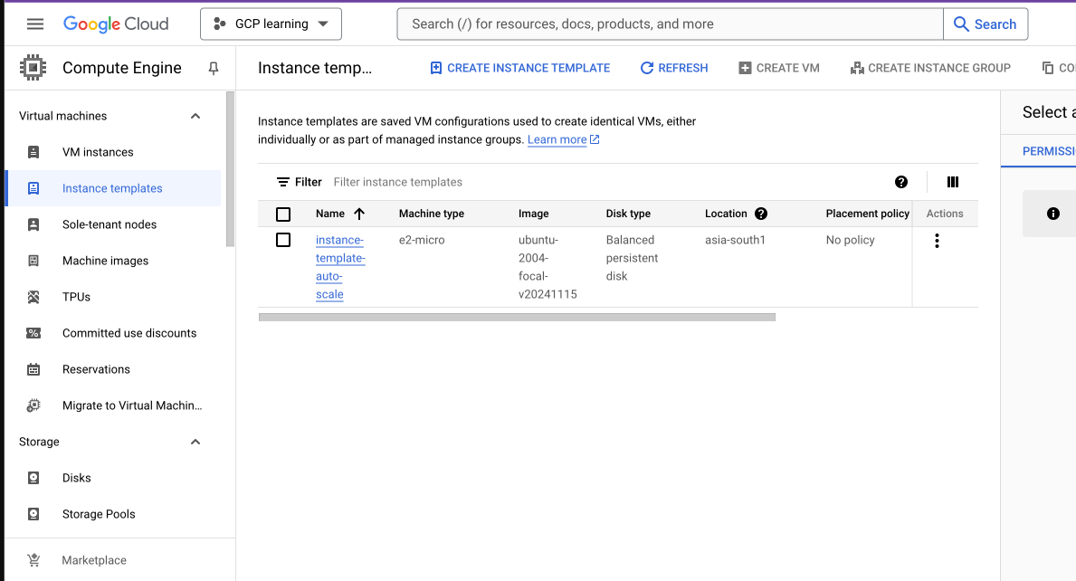

**Instance Group for autoscaling:**

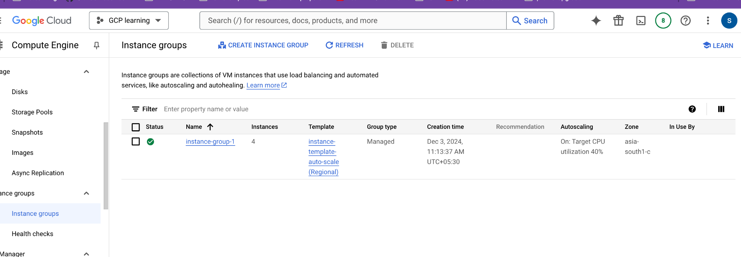

**Terminal view:**

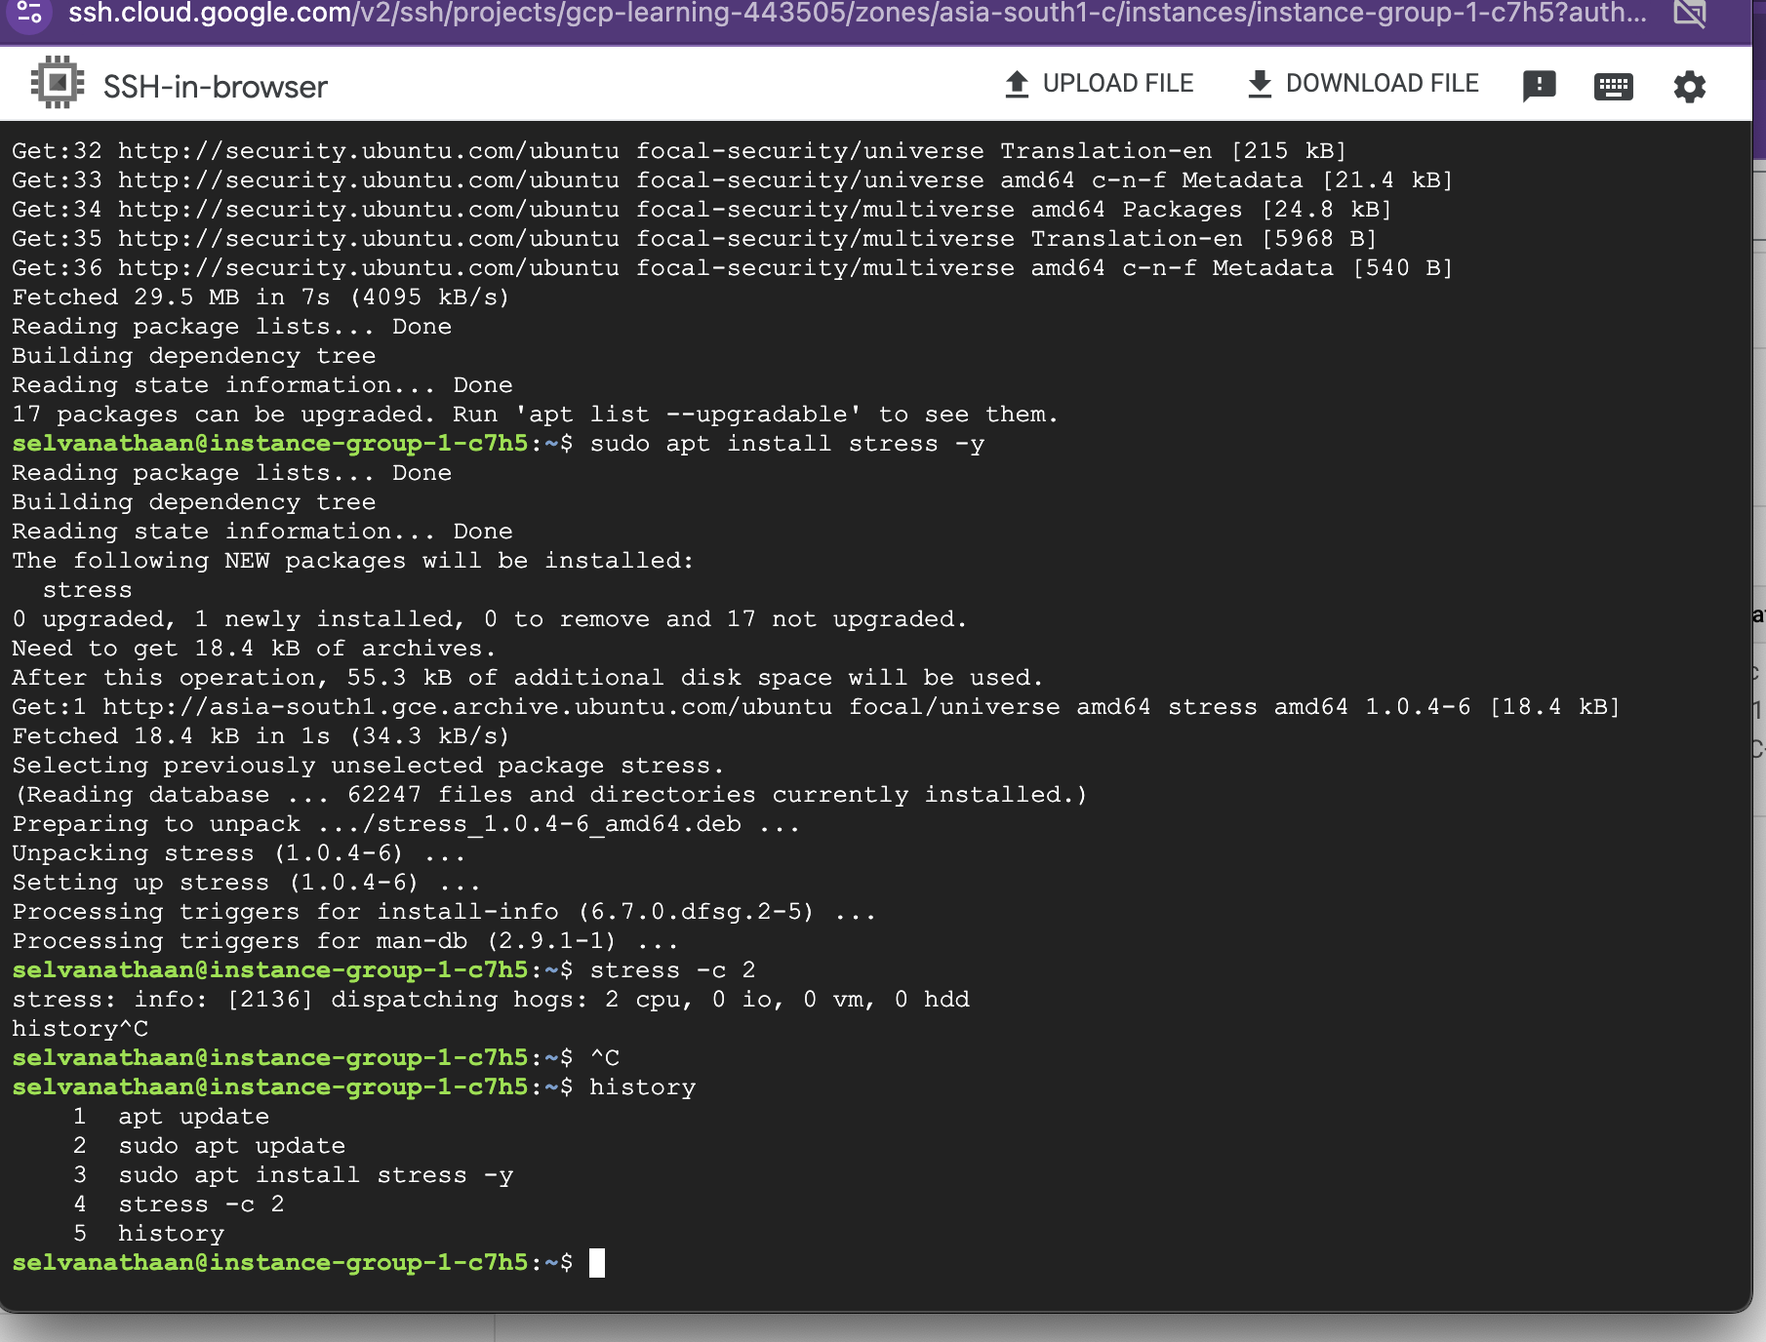

**VM instance after auto scaling: (4 instance)**

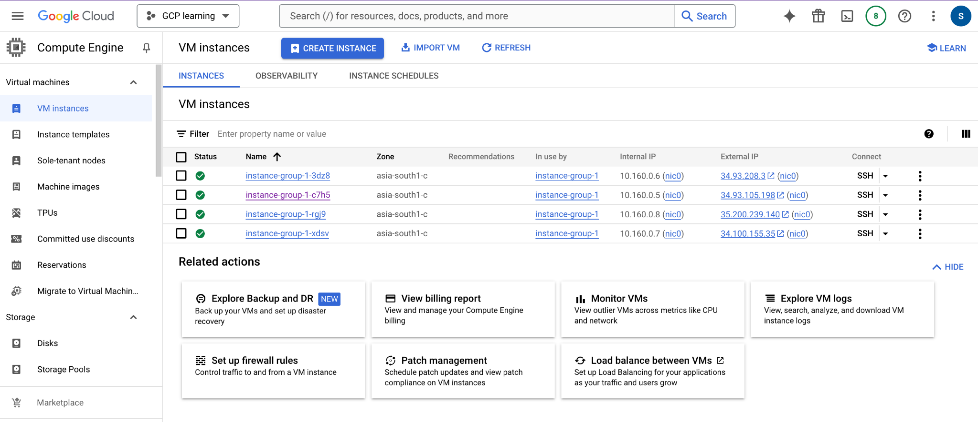

Back to 1 instance

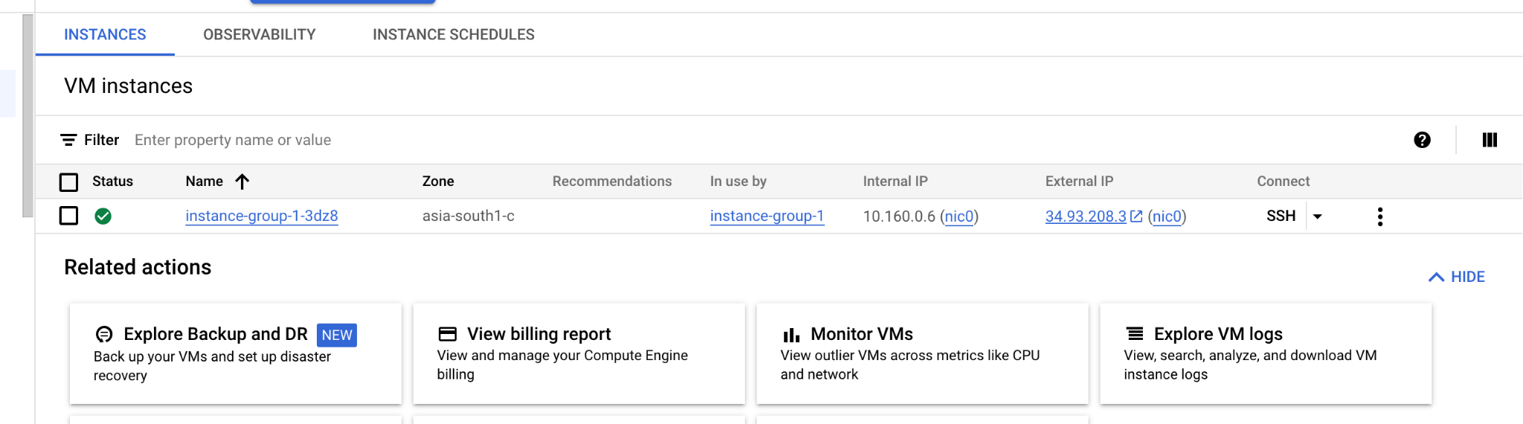

========================================================================

Kubernetes Training

***DAY 1:***

Lab1 - Monolith vs Micro Services

https://martinfowler.com/articles/microservices.html

https://www.atlassian.com/microservices/microservices-architecture/microservices-vs-monolith

Lab2 - Connect to k8s

Option1 - on local machine

Install docker desktop, minikube

minikube status

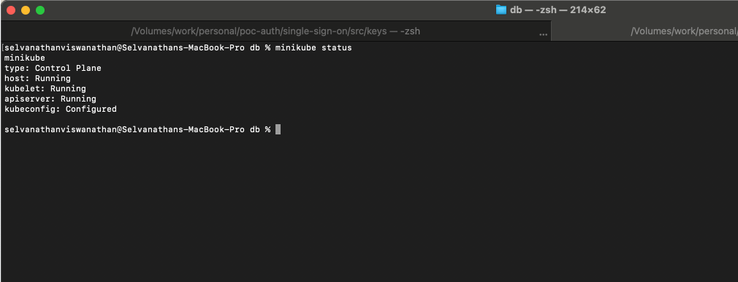

if not started -> minikube start

minikube status

kubectl get nodes

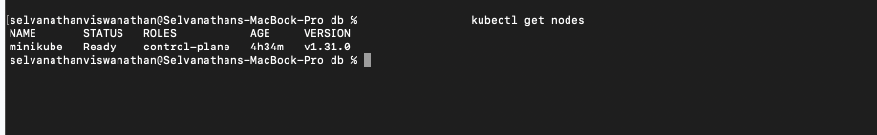

Option2 - google-> k8s playground

https://labs.play-with-k8s.com/

kubeadm

on terminal

kubeadm init --apiserver-advertise-address $(hostname -i) --pod-network-cidr 10.5.0.0/16

kubectl get nodes -> check control-plane status as notready

kubectl apply -f https://raw.githubusercontent.com/cloudnativelabs/kube-router/master/daemonset/kubeadm-kuberouter.yaml

kubectl get nodes -> check control-plane status as ready

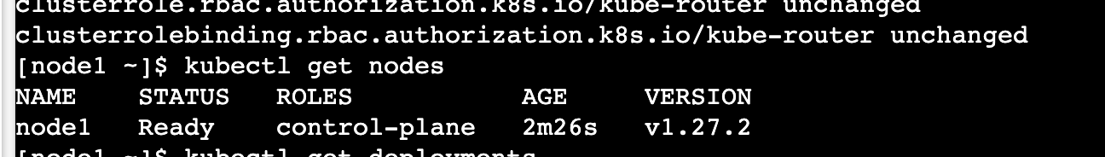

Lab3 - Create simple deployment and observe pod creation/healthcheck and creation of pod again

Option 1 - Minikube

confirm no deployments and no pods

kubectl get deployments

kubectl get pods

create deployment

kubectl create deployment d1 --image=nginx

confirm pod and deployment(1 each)

kubectl get deployments

kubectl get pods (ready as well)

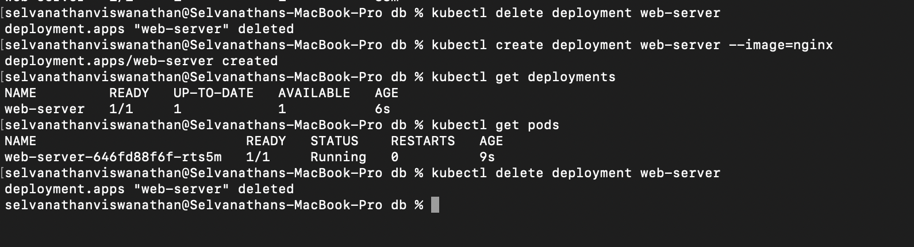

Option 1 - Kubeadm

confirm no deployments and no pods

kubectl get deployments

kubectl get pods

create deployment

kubectl create deployment d1 --image=nginx

confirm pod and deployment(1 each but ready)

kubectl get deployments

kubectl get pods

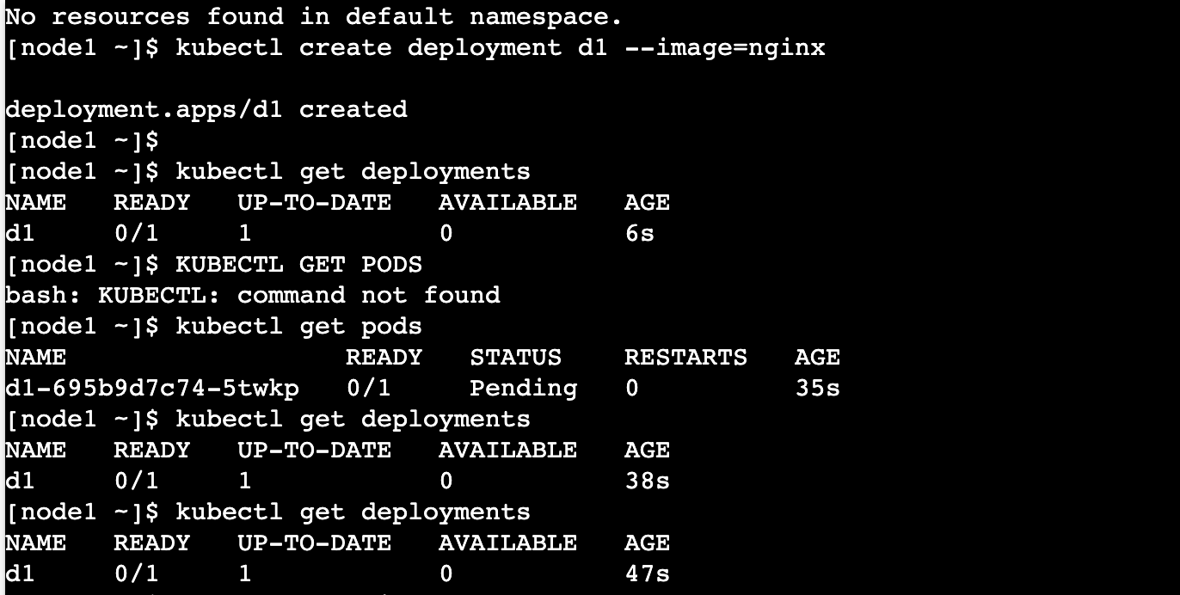

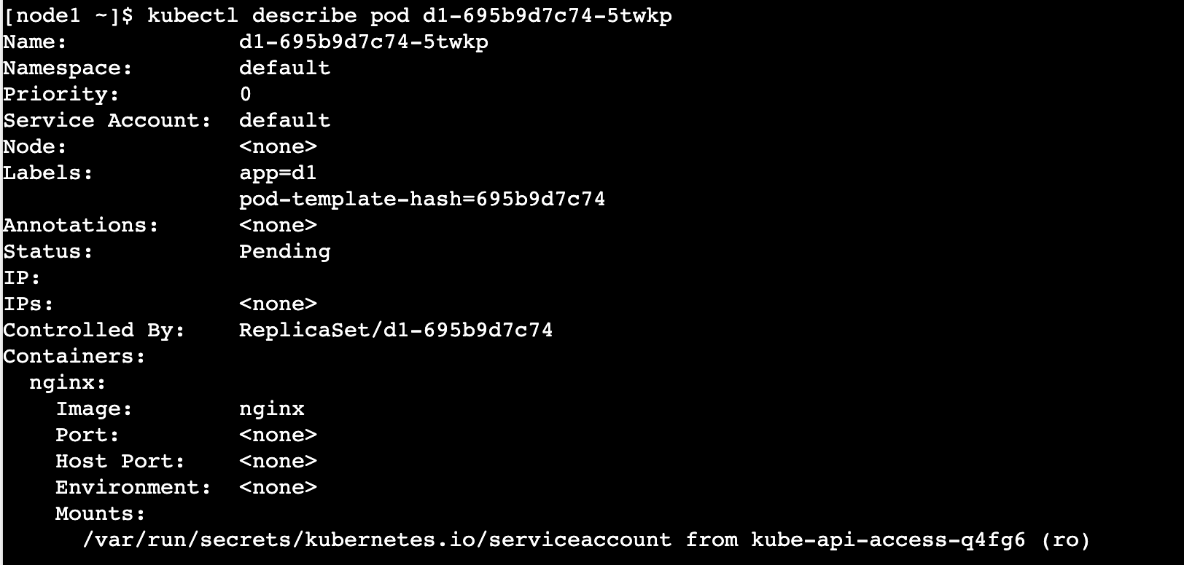

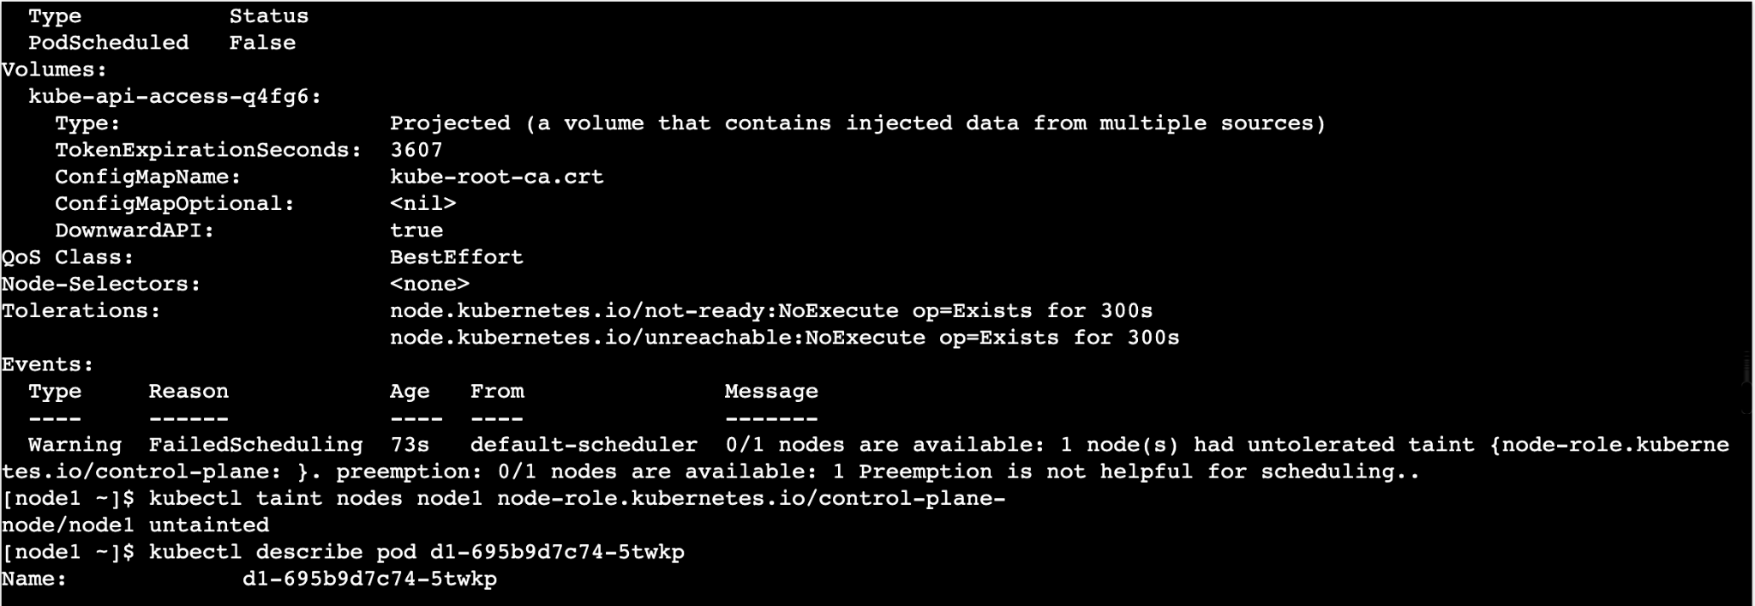

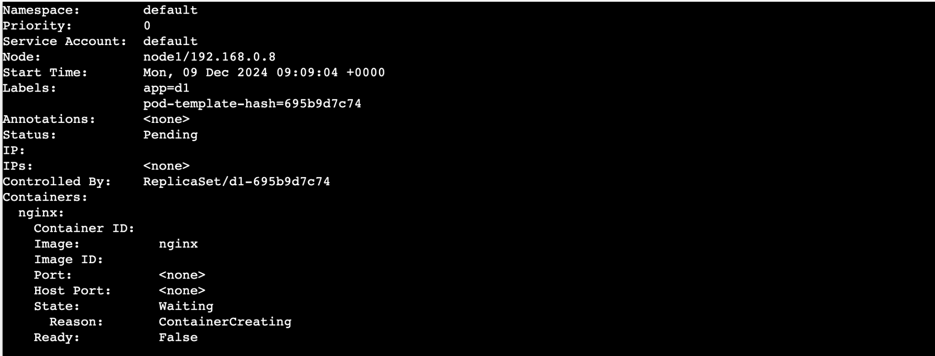

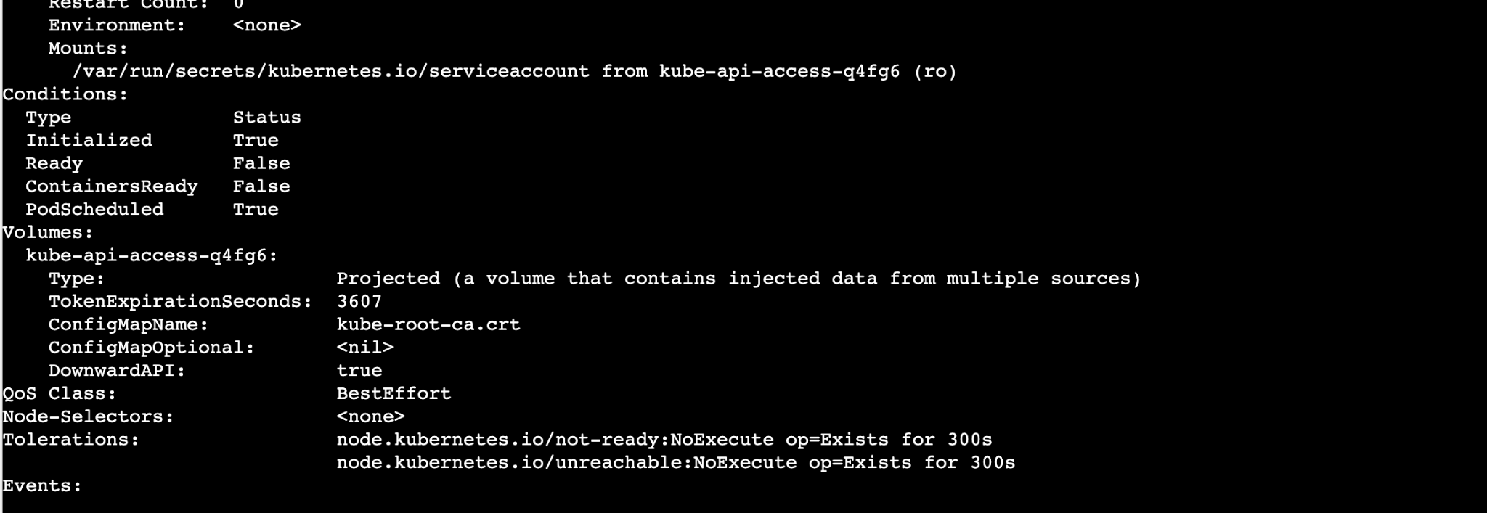

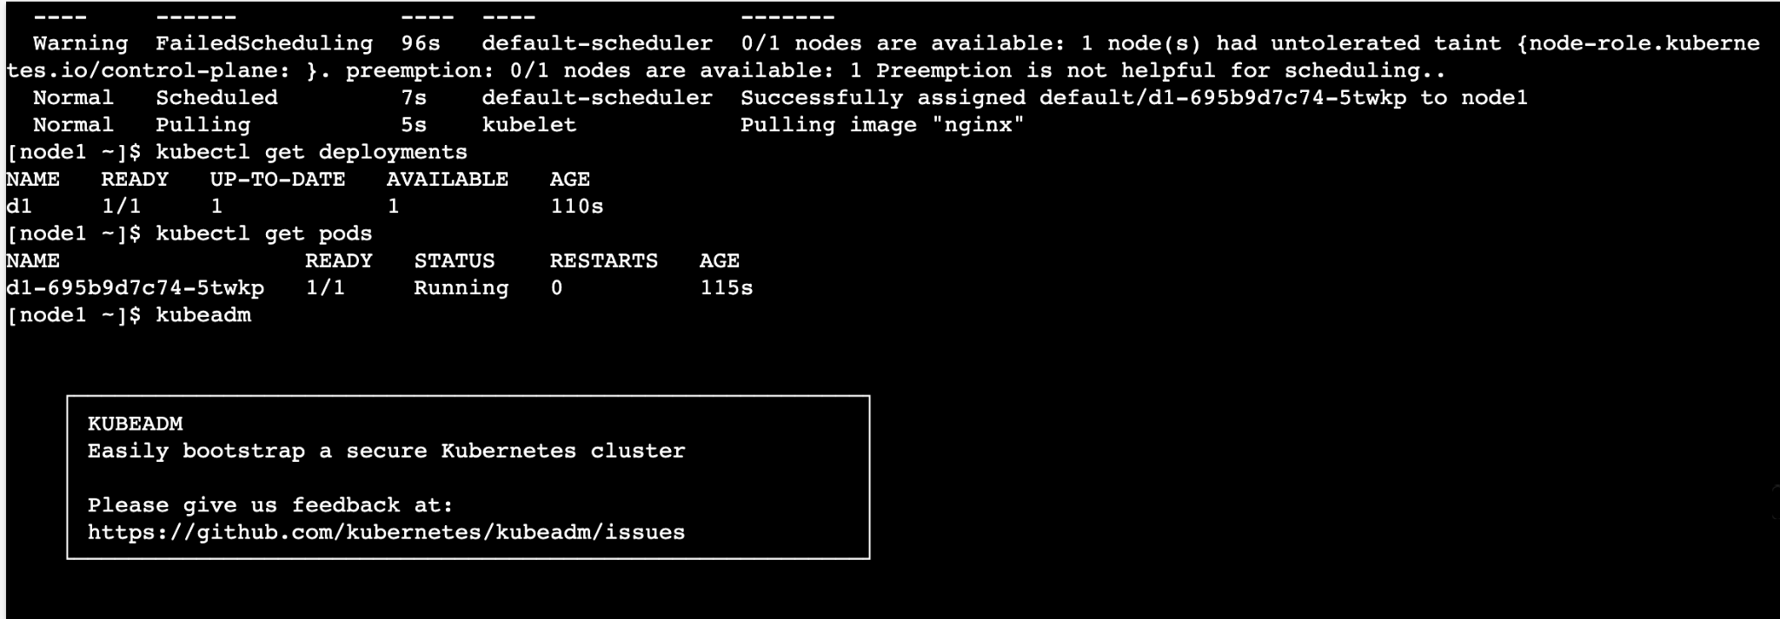

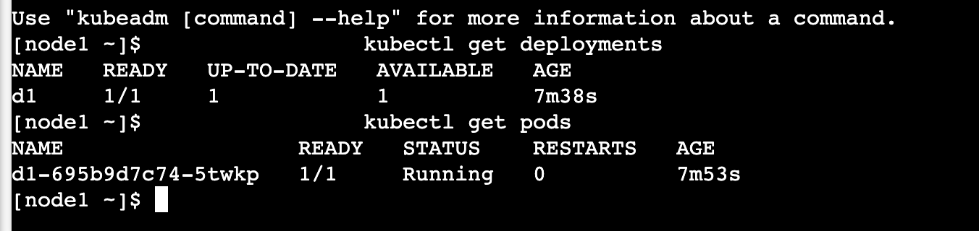

Troubleshooting

reason of pending

kubectl describe pods

read reason

change

kubectl taint nodes node1 node-role.kubernetes.io/control-plane-

confirm by getting pods

delete pod

kubectl delete pod {podname}

kubectl get pods (observe new pod getting creating)

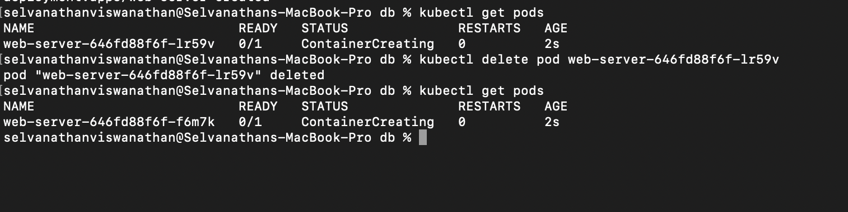

### **For troubleshooting screenshots. Refer above posted screenshots**

Lab4 - deployment(with replica and port) and service

kubectl create deployment d3 --image=nginx --replicas=2 --port=80

confirm deployment and pods (status)

kubectl get pods -o wide

kubectl describe pods {podname}

check port, container, dockerimage etc

create service

kubectl expose deployment d3 --port=8080 --target-port=80

confirm

kubectl get services

confirm endpoints(check pod ip addresses reflected)

To invoke

1. minikube - docker exec minikube curl localhost:8080

2. kubeadm - curl serviceip:8080

Troubleshooting

logs, describe

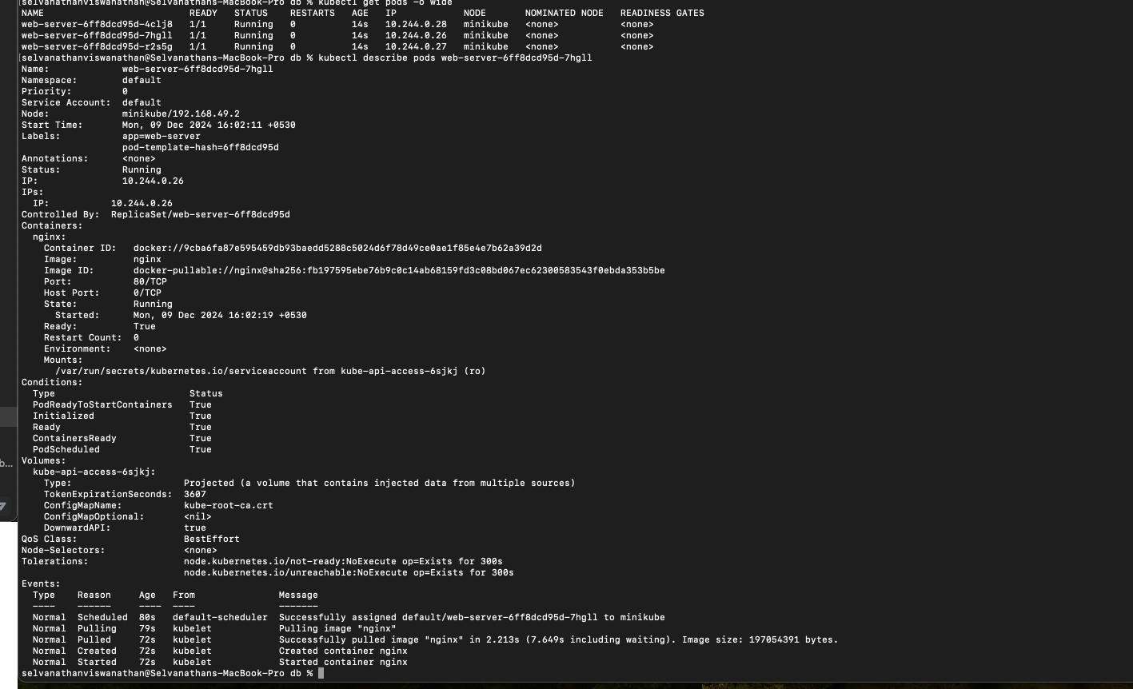

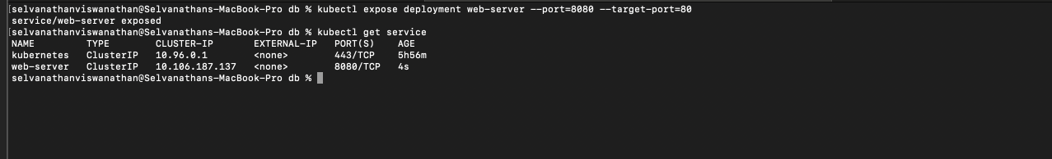

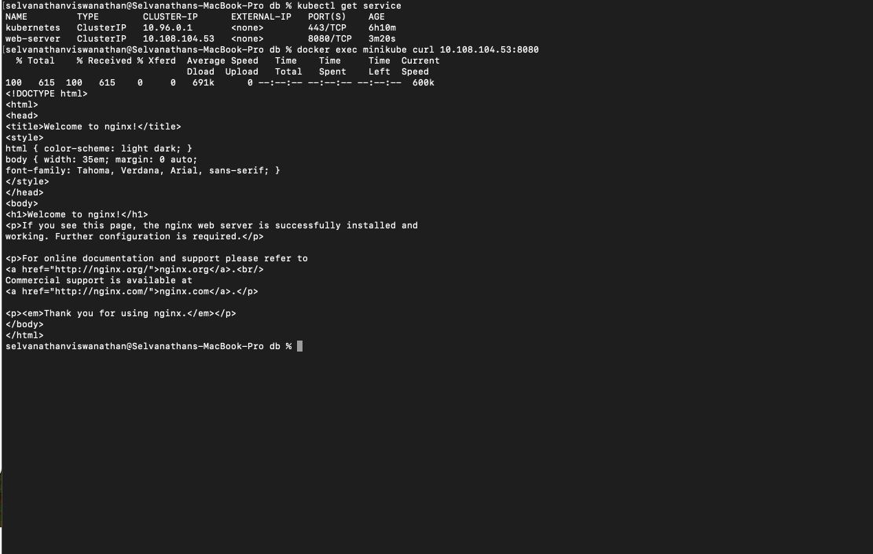

In KubeAdm:

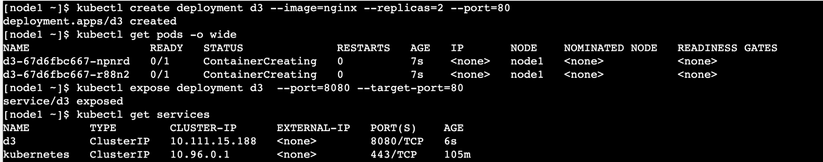

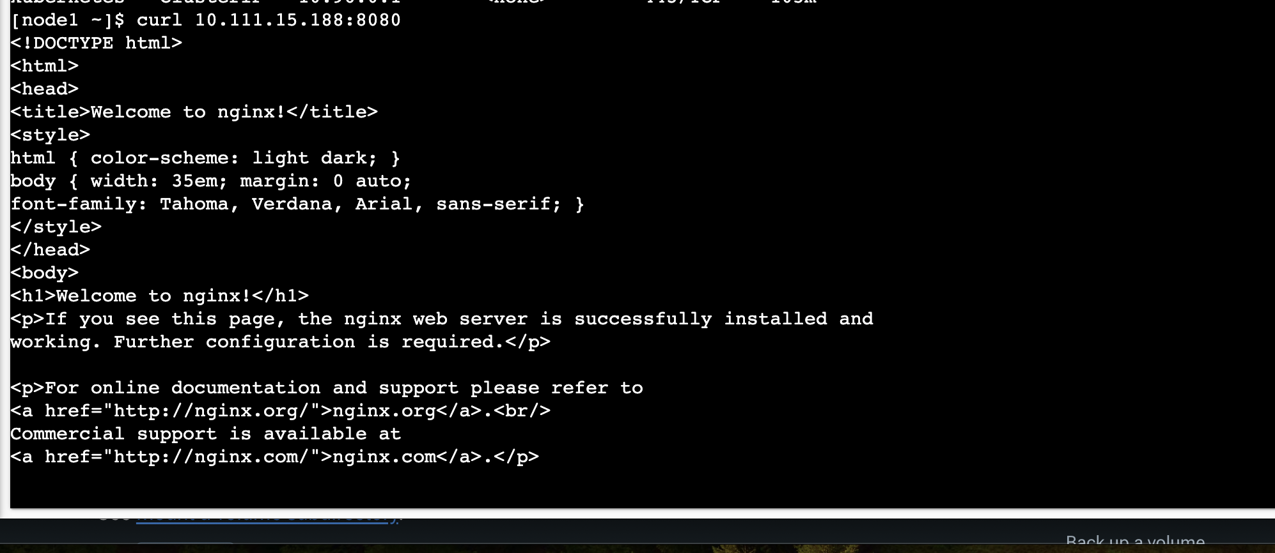

***Lab5:***

**Task: use image - vaishalitapaswi/node8090 (port 8090)**

create 3 replicas

**kubectl create deployment test1 --image=vaishalitapaswi/node8090 --replicas=3**

create service on port 8088

**kubectl expose deployment test1 --port 8088 --target-port=8090**

curl url 5/10 times

**docker exec minikube curl 10.105.222.113:8088**

check logs of pods to see invoked shown on different pods

**kubectl logs test1-d59fc496c-fwpnf**

**kubectl logs test1-d59fc496c-jp9c5**

**kubectl logs test1-d59fc496c-v7tcv**

change replicas to 5 (kubectl edit deployment nameofdeployment )

**// updated in the file and saved it**

observe service endpoints changed to 5 addresses

new pods

**test1-d59fc496c-r8wkh**

**test1-d59fc496c-v7tcv**

**endpoints: 10.244.0.32:8090,10.244.0.33:8090,10.244.0.34:8090 + 2 more...**

curl url 5/10 times

**docker exec minikube curl 10.105.222.113:8088**

check logs of pods to see invoked shown on different pods

**kubectl logs test1-d59fc496c-fwpnf**

**kubectl logs test1-d59fc496c-jp9c5**

**kubectl logs test1-d59fc496c-v7tcv**

**kubectl logs test1-d59fc496c-r8wkh**

**kubectl logs test1-d59fc496c-v7tcv**

Screenshots:

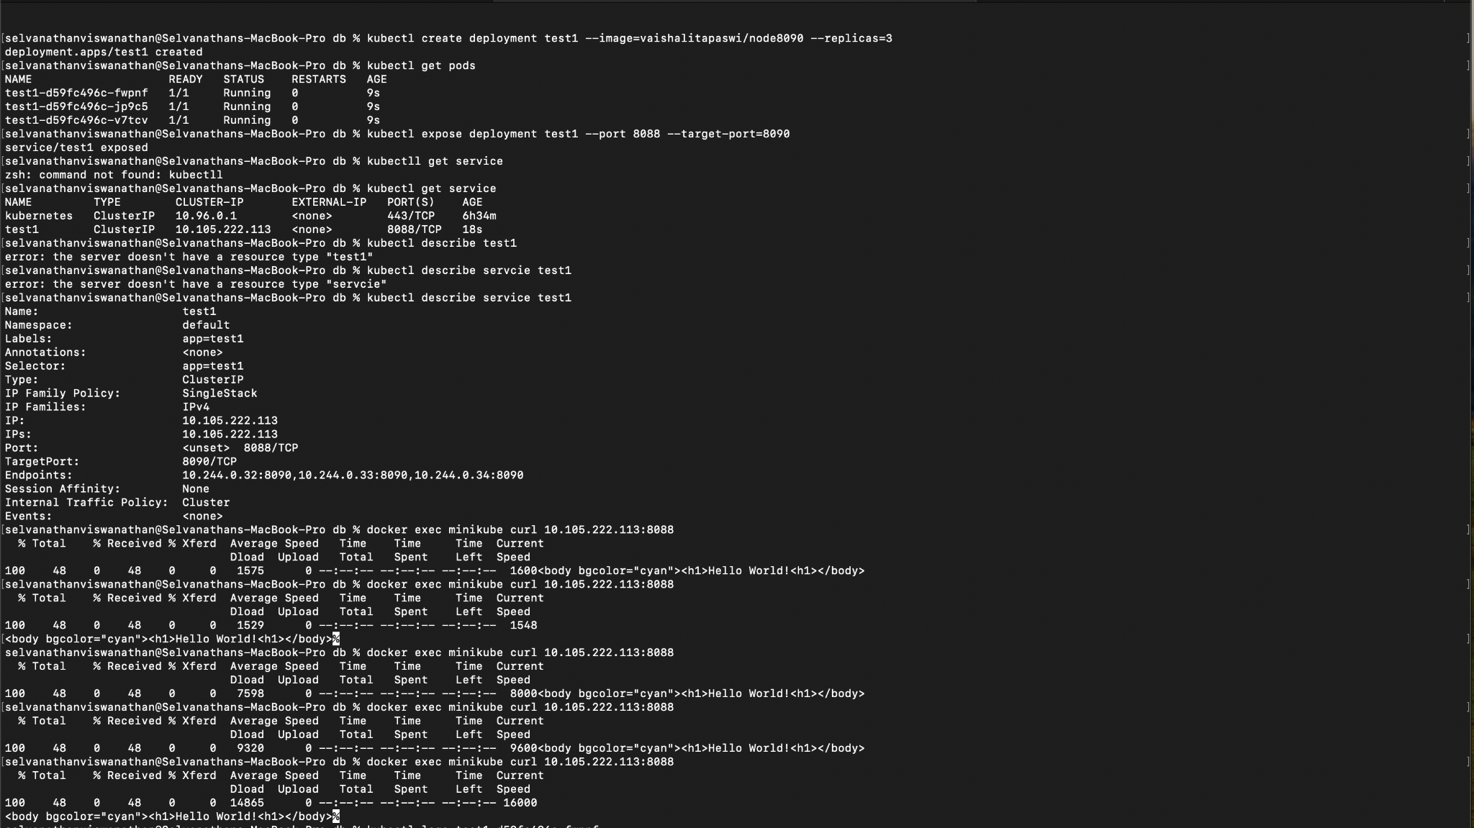

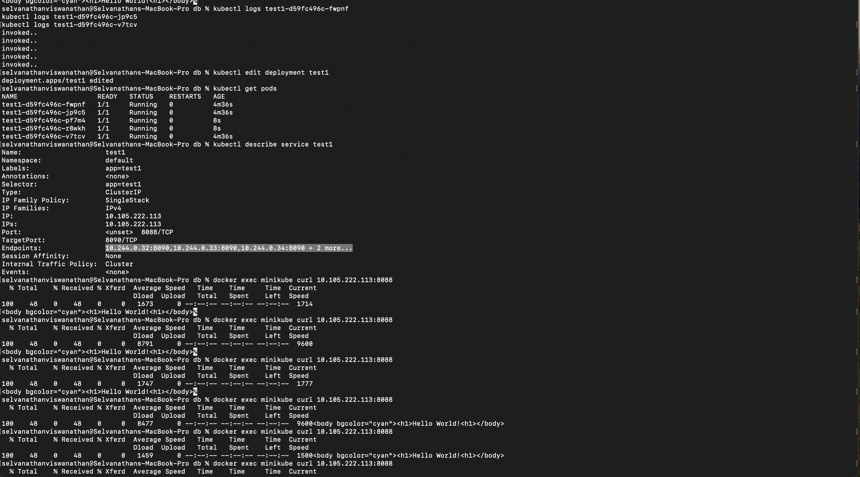



***DAY 2:***

Lab1 - Create deployment using yaml

create file deployment.yaml

---------------------------

apiVersion: apps/v1

kind: Deployment

metadata:

name: myname

labels:

app: myappinlabel

spec:

replicas: 3

selector:

matchLabels:

app: myappintemp

template:

metadata:

labels:

app: myappintemp

spec:

containers:

- name: nginx

image: nginx:1.14.2

ports:

- containerPort: 80

---------------------------

kubectl create -f deployment.yaml

confirm deployments, pods (kubectl get ..)

change pods metadata and watch error

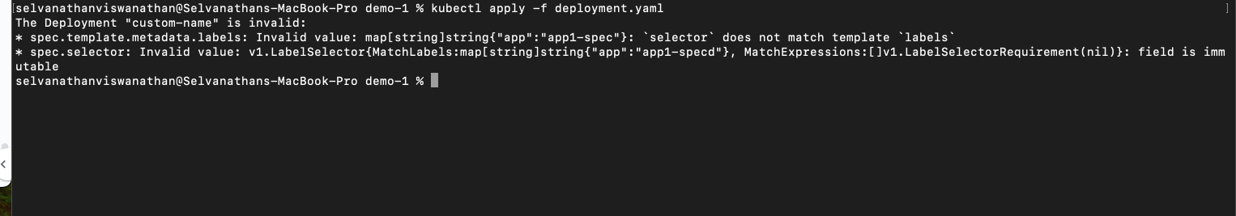

describe deployment and pods to get more details (kubectl describe deployment dname)



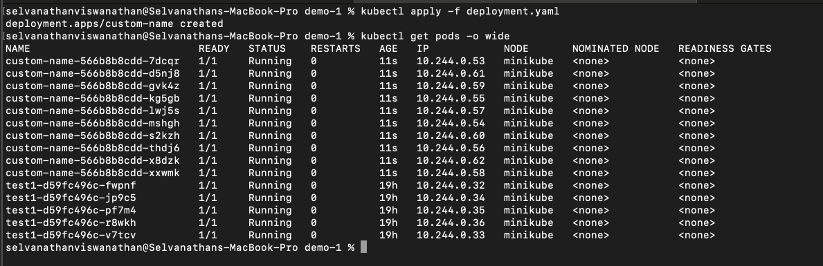

Lab2 - create a single pod

---------------------------

apiVersion: v1

kind: Pod

metadata:

name: podname

labels:

app: myappintemp

spec:

containers:

- name: contname

image: nginx:1.14.2

ports:

- containerPort: 80

---------------------------

kubectl apply -f filename



check pod getting created, delete pod, confirm it is not getting recreated

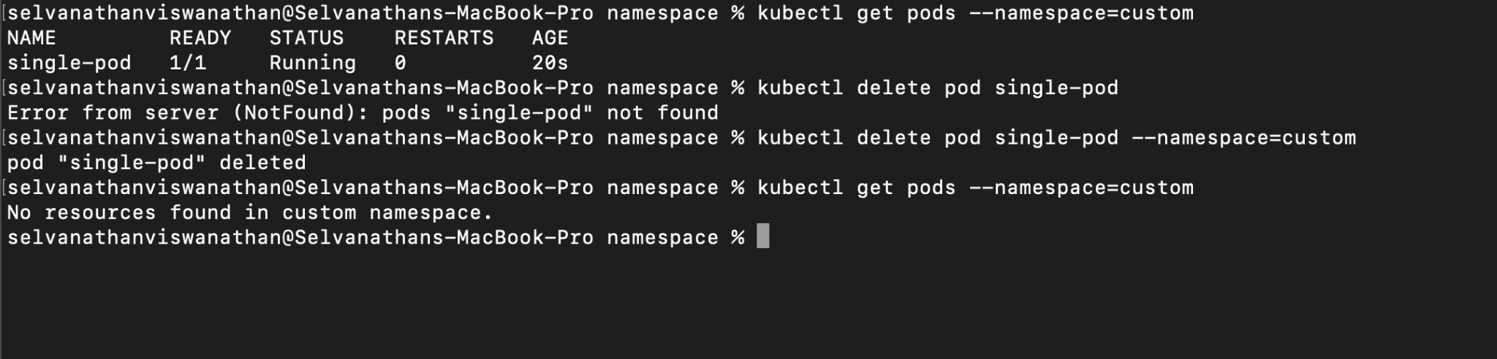

—---—---—---—---—---—---—---—---—---—---—---—---—---—---—---—---—---—---—---—---—---

Lab3 - create a deployment with multicontainer pod

---------------------------

apiVersion: apps/v1

kind: Deployment

metadata:

name: d2

labels:

app: myappinlabel

spec:

replicas: 1

selector:

matchLabels:

app: myappintemp

template:

metadata:

labels:

app: myappintemp

spec:

containers:

- name: nginx1

image: nginx:1.14.2

ports:

- containerPort: 80

- name: nginx1

image: nginx:1.14.2

ports:

- containerPort: 80

---------------------------

create, apply this file, check containers (describe deployment and describe pods)

observe only 1 container is created

modify file to change name of second container as nginx2

try apply, check port error

modify container port of nginx2 to 81 -> apply -> check errors (describe deployment and describe pods)

modify second container -> change name -> , image - tomcat, change port to 8080

apply -> observe 2 containers in pod

Day 3:

Lab1 - create pod.yaml

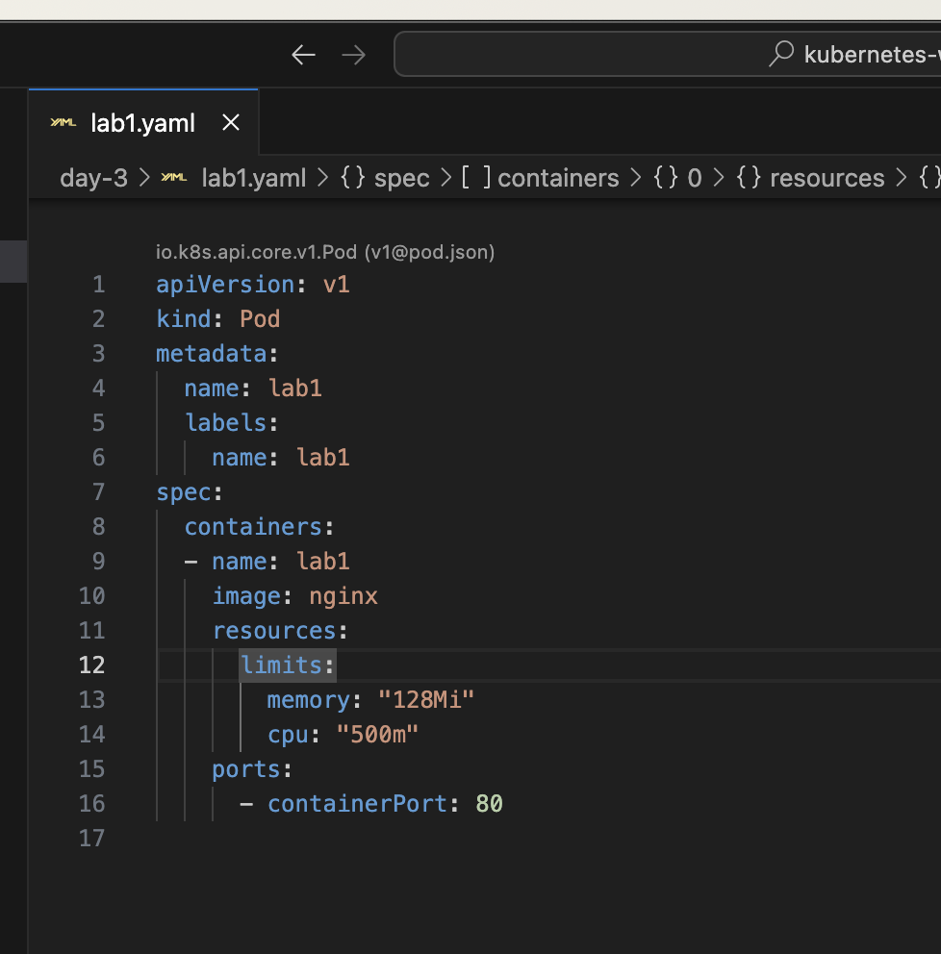

name - demo

image - nginx:latest

port - 80

create pod

connect to pod and replace index.html

kubectl exec -it demo -- /bin/bash

cd /usr/share/nginx/html

echo "<html><body bgcolor='cyan'>Hello World </body></html>" > index.html

exit

check pods ip address(-o wide/describe)

curl http://ipaddress:80

delete and create pod once again

curl http://ipaddress:80

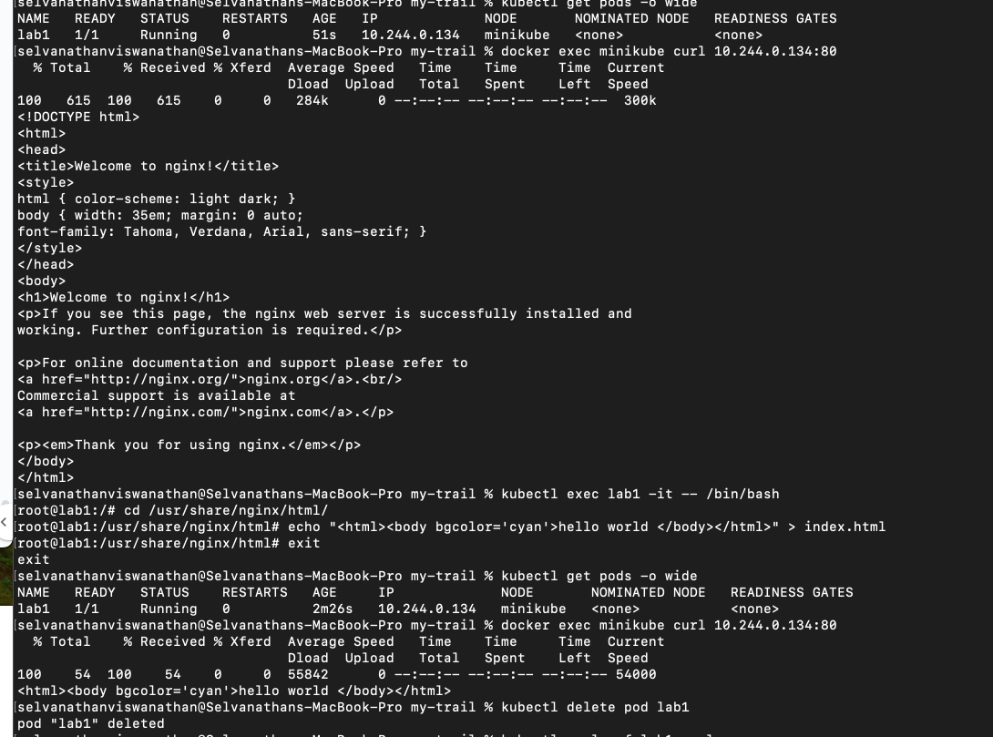clear

our modified index.html is lost

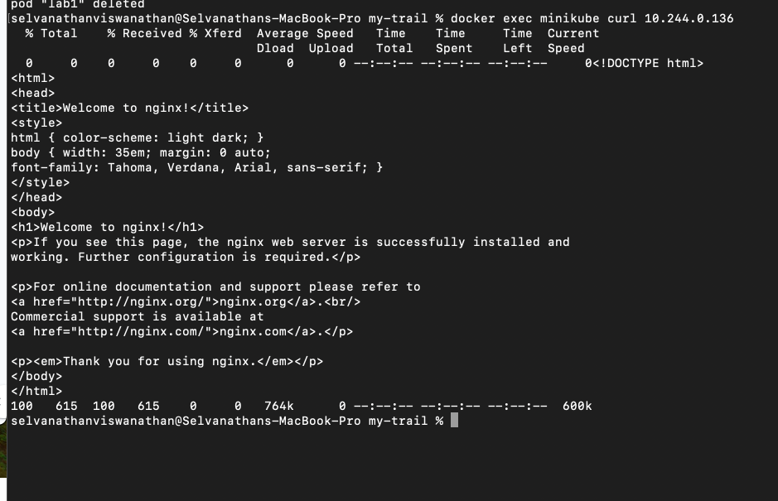

Lab2:

Lab2 - persistent volume and persistent volume claim demo

create pv.yaml

----------------------

apiVersion: v1

kind: PersistentVolume

metadata:

name: mypv

labels:

type: local

spec:

storageClassName: manual

capacity:

storage: 10Gi

accessModes:

- ReadWriteOnce

hostPath:

path: "/mnt/data"

----------------------

create pvc.yaml

----------------------

apiVersion: v1

kind: PersistentVolumeClaim

metadata:

name: pvc123

spec:

storageClassName: manual

accessModes:

- ReadWriteOnce

resources:

requests:

storage: 3Gi

----------------------

create pod1.yaml

----------------------

apiVersion: v1

kind: Pod

metadata:

name: pod1

spec:

volumes:

- name: myvol

persistentVolumeClaim:

claimName: pvc123

containers:

- name: c1

image: nginx:1.14.2

volumeMounts:

- mountPath: "/abc"

name: myvol

----------------------

create pod2.yaml

copy and modify pod1.yaml to change name of pod(pod2) and mountpath as /xyz

create pv (apply )

use get pv to check status (available)

create pvc

get pvc, get pv (check status - bound)

create pod1 and pod2 both and check folder abc and xyz

kubectl exec -it mypod1 -- /bin/bash

create file(echo "aa" >filename ) in pod1 and check its reflected in pod and vice-a-versa

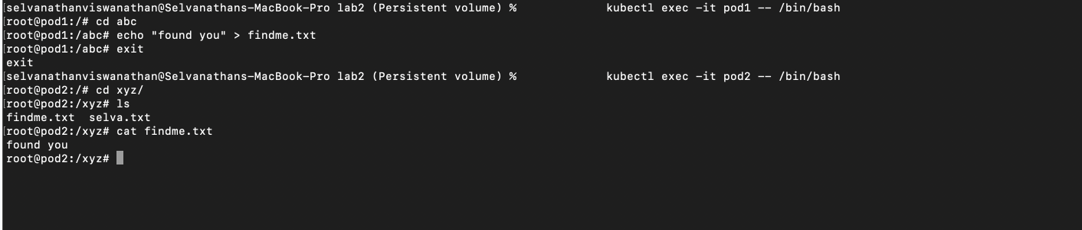

Lab3:

https://kubernetes.io/docs/tasks/configure-pod-container/configure-persistent-volume-storage/

3 different servers(nginx pods) should show same index page

Shift pod.yaml to deployment

Lab3.yaml

apiVersion: apps/v1

kind: Deployment

metadata:

name: lab3

spec:

selector:

matchLabels:

app: shared-mount-app

replicas: 3

template:

metadata:

labels:

app: shared-mount-app

spec:

volumes:

- name: myvol

persistentVolumeClaim:

claimName: pvc123

containers:

- name: shared-mount-app-container

image: nginx

resources:

limits:

memory: "128Mi"

cpu: "500m"

ports:

- containerPort: 80

volumeMounts:

- mountPath: "/usr/share/nginx/html"

name: myvol

---

apiVersion: v1

kind: PersistentVolume

metadata:

name: mypv

labels:

type: local

spec:

storageClassName: manual

capacity:

storage: 10Gi

accessModes:

- ReadWriteOnce

hostPath:

path: "/mnt/data"

---

apiVersion: v1

kind: PersistentVolumeClaim

metadata:

name: pvc123

spec:

storageClassName: manual

accessModes:

- ReadWriteOnce

resources:

requests:

storage: 3Gi

Loggedin to one of the pods and created the index html file

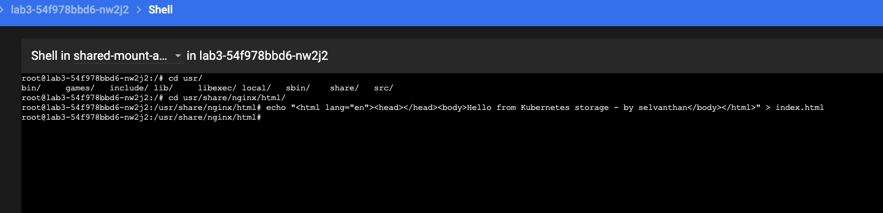

Checked it in the terminal by hitting curl command to port 80.

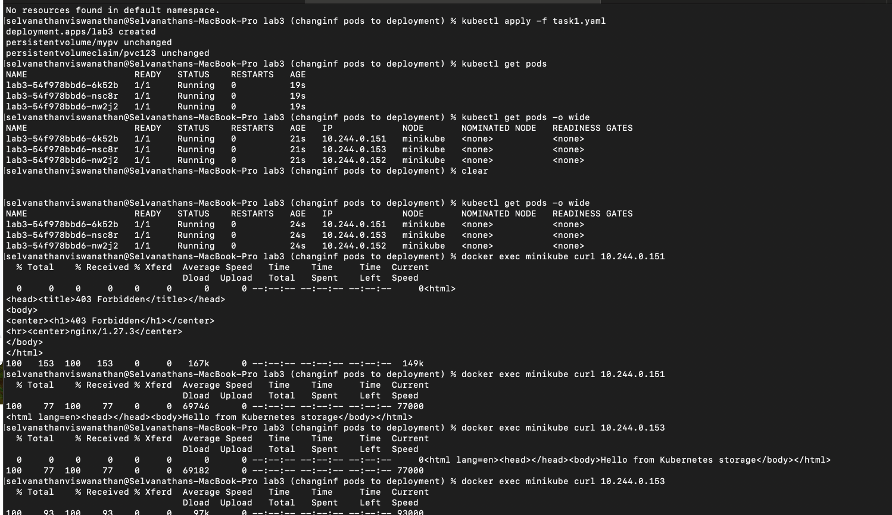

—-----—-----—-----—-----—-----—-----—-----—-----—-----—-----—-----—-----—-----—-----—-----—----

Lab4

create and use namespaces

kubectl get namespace/ ns

kubectl create namespace myns

kubectl get ns

deploy in default namespace

kubectl create deployment d1 --image=nginx

deploy in myns namespace

kubectl create deployment tmp --image=nginx --namespace myns

or kubectl create deployment tmp --image=nginx -n myns

to see pods from all namespaces

kubectl get pods --all-namespaces

kubectl get pods -A

modify the context

kubectl config set-context --current --namespace=myns

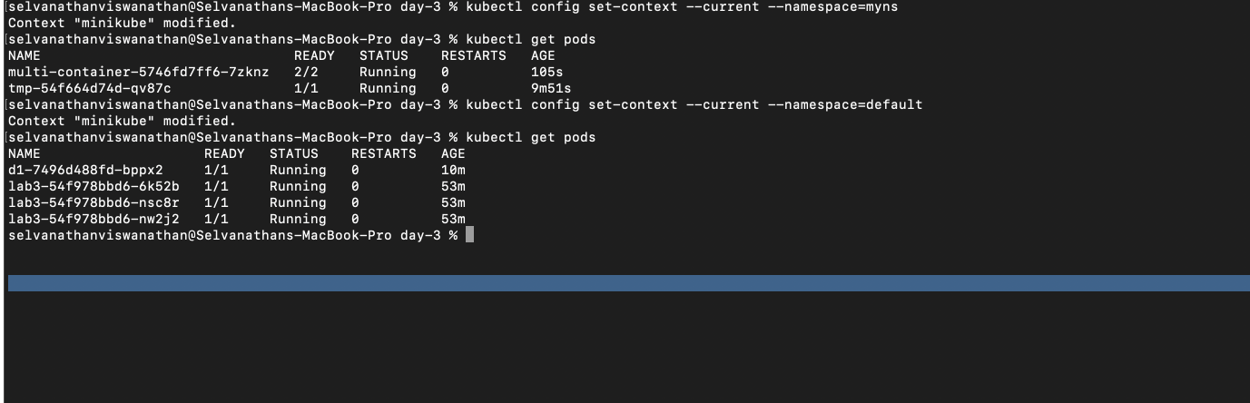

Create a namespace and deployment in that namespace using yaml

show all resources from default namespace

kubectl get all

show all resources from myns

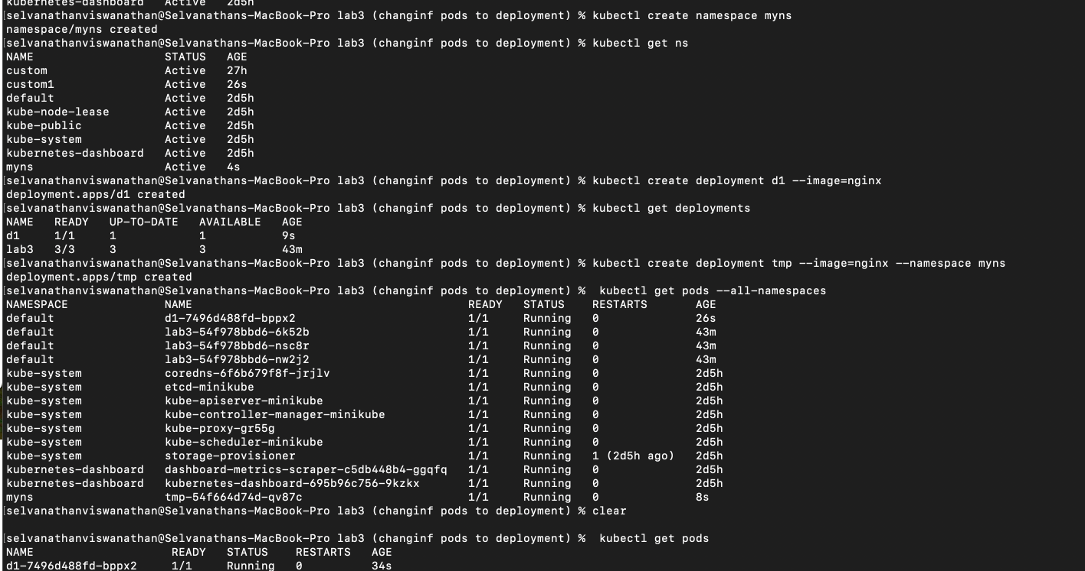

***Creating namespace through yaml:***

apiVersion: v1

kind: Namespace

metadata:

name: custom

***Creating deployment through yaml:***

apiVersion: apps/v1

kind: Deployment

metadata:

name: multi-container

namespace: custom

labels:

app: multi-container

spec:

replicas: 1

selector:

matchLabels:

app: match-multi-container

template:

metadata:

labels:

app: match-multi-container

spec:

containers:

- name: nginx1

image: nginx:1.14.2

ports:

- containerPort: 80

- name: tomcat

image: tomcat

ports:

- containerPort: 8080

***Result***: